
REPUBLIC OF CAMEROON
PEACE-WORK-FATHERLAND
UNIVERSITY OF BUEA
FACULTY OF ENGINEERING AND TECHNOLOGY

DEPARTMENT OF COMPUTER ENGINEERING

CEF 440: INTERNET PROGRAMMING AND MOBILE PROGRAMMING

TASK 5: UI DESIGN AND IMPLEMENTATION

COURSE INSTRUCTOR: Dr Nkemeni Valery

PRESENTED BY GROUP 8:

SALLE YIMNAI BRYAN NZUME ETUGE: FE23A140
MANIKEU TINKEU MARIE ANGE PRINCESSE: FE23A086
FONGANG FAITH ACHO: FE23A059
ANDIGEMA JOYCE ANI: FE23A012
NDIP SAMUEL AGBOR OJONG: FE23A101

Table of Contents
1. Introduction 1
1.1 Task Objectives 1
1.2 Project Background and Design Inputs 1
1.3 Scope of This Deliverable 1
1.4 Tools and Technologies 2
2. App Identity 2
2.1 Product Name 3
2.2 Logomark 3
2.3 Tagline and Brand Promise 3
2.4 Brand Personality and Voice 3
2.5 Brand Direction Selection 4
3. Visual Design 4
3.1 Design Principles 5
3.2 Colour System 5
3.3 Typography 6
3.4 Spacing, Shape and Elevation 7
3.5 Iconography 7
3.6 Core UI Components 7
3.7 Accessibility 8
3.8 Screen Inventory and Visual Walkthrough 8
3.8.1 Home hub 12
3.8.2 Result and safety 12
3.8.3 Engine sound 12
3.8.4 Repair and maintenance 13
4. Frontend Implementation 13
4.1 Architecture Overview 13
4.2 Technology Stack 13
4.3 Project Structure 14
4.4 Domain Model and Knowledge Base 14
4.5 Data Layer and Backend-Readiness 15
4.6 Navigation 15
4.7 State Management 15
4.8 Theming and Rendering 16
4.9 Diagnostic Flows and Safety Behaviour 16
4.10 Permissions and Privacy 16
4.11 Offline-First Behaviour 17
4.12 Build and Run 17
4.13 Requirements Traceability 17
5. Challenges and Key Design Decisions 18
5.1 Choosing a reassuring identity over a technical one 18
5.2 Communicating uncertainty responsibly 18
5.3 Designing safety interruptions that are actually read 18
5.4 Building a frontend that does not have to be rewritten 18
5.5 Custom navigation for rich screen parameters 18
6. Conclusion 18

1. Introduction

1.1 Task Objectives
This report documents Task 5 of the CarDiag project: the User Interface (UI) design and implementation of the mobile application for car fault diagnosis. As specified in the course outline, Task 5 comprises three deliverables:
- App Identity - the product name, logomark, tagline, brand personality and positioning that give the application a recognisable and trustworthy character.
- Visual Design - the design system that governs the look and feel of every screen: colour, typography, spacing, shape, iconography, components and accessibility.
- Frontend Implementation - the native Android application that realises the design, including its architecture, technology stack, screens, navigation, state management and build process.
All three deliverables build directly on the artefacts produced in the preceding tasks. The functional and non-functional requirements baselined in the Software Requirements Specification and the system models produced in Task 4 (context, data-flow, use-case, sequence, class and deployment diagrams) are the design inputs that this task turns into a working interface.

1.2 Project Background and Design Inputs
CarDiag is an offline-first mobile application that helps non-technical car owners understand dashboard warning lights and unusual engine sounds. It offers three diagnostic pathways - camera-based warning-light recognition, engine-sound recording and classification, and a guided symptom questionnaire - and for every result it returns a plain-language explanation, an urgency classification, a confidence indicator, tiered repair suggestions, and a mandatory safety disclaimer with a mechanic-referral prompt.
Task 4 fixed the implementation platform in its deployment diagram: the UI layer is to be built with Kotlin and Jetpack Compose on Android, organised using the Model–View–ViewModel (MVVM) pattern, with on-device processing and a bundled knowledge base so that core features work without an internet connection. The present task adopts those decisions directly.
Before native development began, the design was prototyped as an interactive, high-fidelity clickable mock-up of all sixteen screens. The prototype explored two candidate brand directions and served as the visual source of truth for the Android build. This report describes both the design that was settled on and the Android frontend that implements it.

1.3 Scope of This Deliverable
In agreement with the project schedule, Task 5 delivers a complete frontend. The diagnostic intelligence (the machine-learning models) and the online services (database synchronisation and expert-video links) belong to later tasks; in this build they are represented by clearly isolated software interfaces whose only current implementations return realistic mock results. This keeps the user experience complete and demonstrable today, while ensuring that the backend, database and on-device models from Task 6 and beyond can be attached later by providing new implementations of those interfaces, without modifying any screen. Section 4 explains this seam in detail.

1.4 Tools and Technologies
Concern | Tool / Technology | Role
Design & prototyping | High-fidelity interactive prototype (HTML/CSS/JS) | Explore brand directions; lock the visual system and screen flows.
Language | Kotlin 2.0.21 | Primary implementation language for the Android app.
UI toolkit | Jetpack Compose (BOM 2024.12.01) + Material 3 | Declarative, component-based UI for all screens and widgets.
IDE / build | Android Studio; Android Gradle Plugin 8.7.3; Gradle 8.14 | Project tooling, dependency management and APK assembly.
Typography | Downloadable Google Fonts (Sora, Plus Jakarta Sans, IBM Plex Mono) | Brand typefaces loaded at runtime with graceful fallback.
Target platform | Android 8.0+ (minSdk 26), compiled against the latest installed SDK | Wide device coverage, consistent with NFR07.

2. App Identity
App identity is the set of recognisable, repeatable signals that tell a user what the application is, who it is for, and how it behaves. For a diagnostic tool that touches driver safety, identity is not decoration - it is the foundation of trust. The identity below was shaped by a central finding from requirement gathering: drivers want help understanding their car, but they (and mechanics) are wary of a tool that over-claims. CarDiag therefore presents itself as a calm, honest assistant rather than an authority.
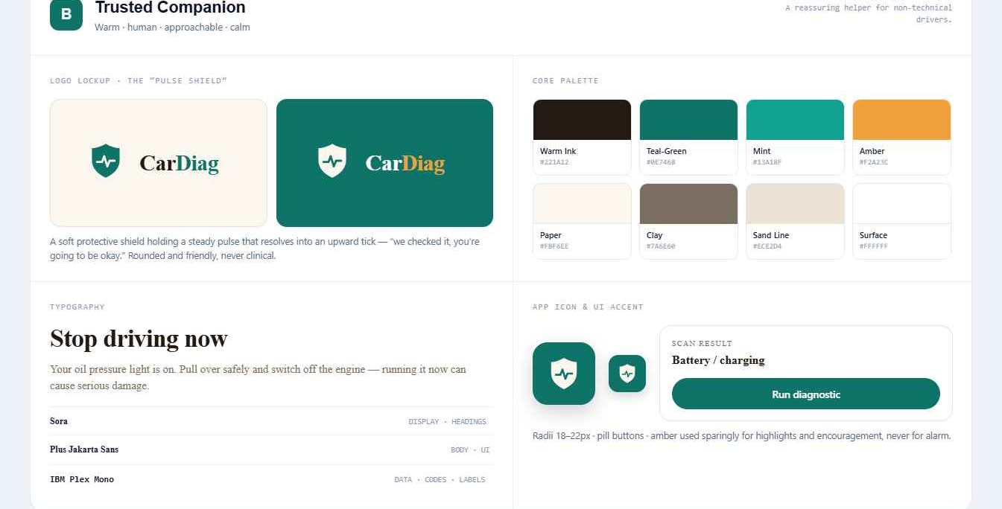
Figure 1: The CarDiag brand board for the selected “Trusted Companion” direction - logomark, core palette, typography and app icon. Sections 2 and 3 reference it throughout.

2.1 Product Name
The application is named CarDiag, a contraction of “Car Diagnosis”. The name is short, pronounceable, and descriptive: it states the product’s purpose without technical jargon, which suits a non-technical primary audience. In the wordmark, “Car” is set in the primary ink colour and “Diag” in the brand accent, so the diagnostic half of the name is visually emphasised.

2.2 Logomark
The logomark is a shield enclosing a pulse/heartbeat line that rises into a sharp peak. The two elements were chosen deliberately:
- The shield communicates protection, safety and trust - the application looks out for the driver.
- The pulse line communicates diagnosis and the “vital signs” of the vehicle, echoing the waveform used on the engine-sound feature.
The mark is built as a scalable vector so it renders crisply at every size, from the small header badge to the large splash-screen lockup. It has two finishes: a solid-fill version for light backgrounds and an inverted (outline) version that glows on the dark immersive screens. Because it is geometric and single-weight, it also works as the basis of the adaptive launcher icon (see Figure 1).

2.3 Tagline and Brand Promise
The product tagline is “Your pocket diagnostic”, reinforced on the splash screen by the line “Works fully offline”. Together they make two promises that the requirements identified as decisive for adoption: the tool is always with you, and it does not depend on a network connection or data bundle.
The deeper brand promise is stated on the home screen and repeated throughout: “An assistant, not a replacement.” CarDiag helps the driver understand a problem and decide the next step; a qualified mechanic still confirms the fix. This single sentence resolves the trust tension uncovered during requirement gathering and governs the tone of every result screen.

2.4 Brand Personality and Voice
CarDiag’s personality is calm, plain-spoken and protective. Its voice avoids alarmist or highly technical language and instead explains faults in everyday terms - for example, “Possible engine timing problem. Visit a mechanic soon” rather than “potential crankshaft synchronisation anomaly”. Urgency is communicated honestly but without panic, and the app never pretends to be certain when it is not.
Trait | How it shows up in the product
Honest | Confidence is always shown; a low-confidence result never names a specific fault.
Calm | Warm neutral palette, generous spacing, no harsh reds except for genuine danger.
Protective | Mandatory safety disclaimer on every result; non-dismissible warning for critical faults.
Plain-spoken | Short sentences, everyday words, one clear next action labelled “Do this first”.
Accessible | Designed for a non-technical owner to complete a check in no more than three taps.

2.5 Brand Direction Selection
Two brand directions were prototyped before committing to one:
- Direction A - “Diagnostic Instrument”: a cool, technical, high-contrast look (cyan on near-black, tight geometric type and a gauge logomark). It reads as a precision tool.
- Direction B - “Trusted Companion”: a warm, friendly, reassuring look (deep green on a soft paper background, rounded shapes, the pulse-shield logomark). It reads as a helpful guide.
Direction B was selected as the production identity. The requirement evidence pointed consistently to non-technical owners who delay action out of uncertainty and who are wary of automated tools; a reassuring, human, low-anxiety identity supports adoption and trust better than a clinical one. All visual design and implementation described below realise Direction B.
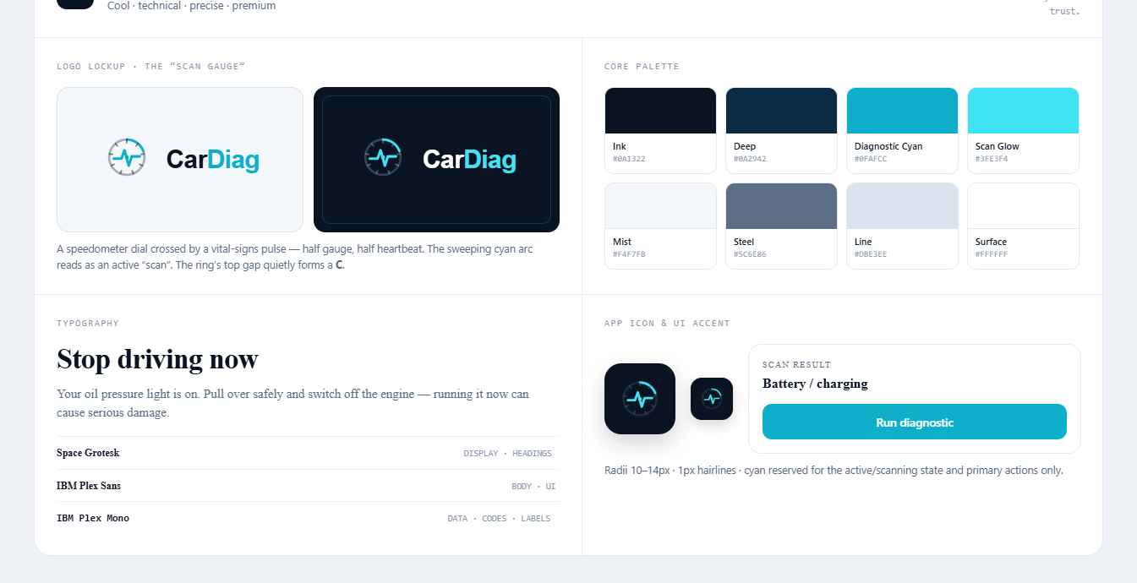
Figure 2: The rejected alternative - Direction A, “Diagnostic Instrument”: a cooler, more technical treatment (cyan on near-black, a gauge logomark). The warmer Direction B in Figure 1 was chosen instead.

3. Visual Design
The visual design is expressed as a small, consistent design system - a single source of colour, type, spacing, shape, iconography and components that every screen draws from. A token-based system keeps the interface coherent, makes it accessible by construction, and (because the tokens are defined once in code) makes future theming or a dark mode straightforward.

3.1 Design Principles
- Clarity over completeness - show the one thing the user must do first, then supporting detail.
- Safety is non-negotiable - every result carries a disclaimer; dangerous faults interrupt the flow deliberately.
- Honest uncertainty - confidence is always visible and suppresses specific claims when low.
- Offline by default - offline status is shown as a calm, positive cue, never an error.
- Reachable in three taps - the primary task (run a check) is never more than three taps from home (NFR01).
- Never colour alone - urgency is conveyed by colour and a text label and an action phrase (NFR11).

3.2 Colour System
The palette is warm and low-glare: a soft paper background with deep-green brand accents. Colour is used sparingly so that the urgency colours always stand out when they appear.
Token | Hex | Role
Background | #FBF6EE | App canvas (warm paper)
Surface | #FFFFFF | Cards, sheets, list rows
Surface-2 | #F5EEE2 | Insets and secondary fills
Ink | #221A12 | Primary text
Muted | #7A6E60 | Secondary text
Faint | #A99C8C | Hints, metadata, placeholders
Line | #ECE2D4 | Borders and dividers
Primary | #0E7468 | Brand green; primary actions
Primary-deep | #0B5A50 | Pressed state, icon accents
Glow | #13A18F | Highlight on dark surfaces
On-primary | #FFFFFF | Text/icons on primary
Chrome | #0B3A34 | Dark immersive backgrounds (splash, camera, sound)

Urgency colour system. Every diagnostic result is classified into one of four urgency levels (FR08). Each level pairs a distinct colour with a fixed label and a plain-language action, so the meaning never depends on colour perception alone.
Level | Colour | Label | Action shown to the user
Low | #1FA85A (green) | Low | Monitor - safe to keep driving
Medium | #C8920A (amber) | Medium | Service soon - book a mechanic in a few days
High | #E0660F (orange) | High | Mechanic today - visit a mechanic today
Critical | #E11D48 (red) | Critical | Stop driving now - stop as soon as it is safe
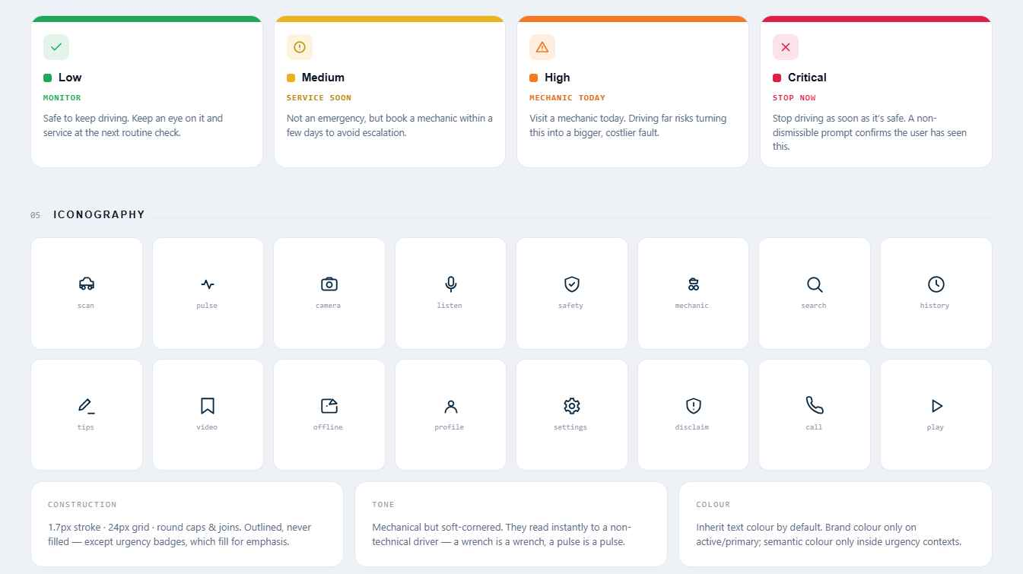
Figure 3: The shared four-level urgency scale (top) and the CarDiag interface icon family (referenced in Section 3.5). Every urgency level pairs colour with an icon and a text label, never colour alone.

3.3 Typography
Three typefaces, all loaded as downloadable Google Fonts with a safe system fallback, give the interface a clear voice and hierarchy:
- Sora (display) - screen titles, section headers and result names; geometric and confident.
- Plus Jakarta Sans (body) - all reading copy; humanist, friendly and highly legible at small sizes.
- IBM Plex Mono (mono) - small upper-case “eyebrow” labels, numeric values and metadata; signals precision and the technical underpinning.

Role | Typeface | Size / weight | Usage
Heading 1 | Sora | 26 / 700 | Screen titles, result fault name
Heading 2 | Sora | 20 / 700 | Section headers, modal titles
Heading 3 | Sora | 16 / 600 | Card titles
Body | Plus Jakarta Sans | 15 / 400–500 | Primary reading copy
Lead | Plus Jakarta Sans | 14.5 / 400 | Secondary, muted copy
Caption | Plus Jakarta Sans | 12–13 / 500 | List subtitles, hints
Section label | IBM Plex Mono | 10.5 / 500 (upper-case) | Eyebrow labels, metadata
The three families in use are shown in the brand board (Figure 1). The sizes above are the in-app UI sizes for the application screens; they are independent of the typographic settings of this report document.

3.4 Spacing, Shape and Elevation
Spacing follows a simple rhythm based on multiples of four, with a standard screen padding and consistent gaps between cards. Shape is the most distinctive expression of the “Trusted Companion” direction: corners are generously rounded (cards at a large radius, smaller controls slightly less) and primary buttons and chips are fully rounded “pill” shapes. Elevation is kept very subtle - cards sit on the paper background with hairline borders and only a faint shadow - so the interface feels soft and uncluttered rather than heavy.

3.5 Iconography
Two coordinated icon sets were drawn specifically for the app, both on a 24-unit grid with a consistent 2-pixel stroke and rounded line ends so they feel like one family:
- Interface icons - navigation (home, history, vehicle, settings, chevrons), actions (camera, microphone, search, wrench, play, phone, edit, delete), and status (shield, alert, information, check, lock, offline/Wi-Fi-off, bolt). Repair tiers have their own glyphs (open hand, spanner, mechanic).
- Dashboard warning-light symbols - eight recognisable reproductions of real dashboard tell-tales (oil pressure, coolant temperature, battery/charging, brake system, check-engine, ABS, tyre pressure and airbag/SRS) so users can match what they see on their own dashboard.
Drawing the icons as vectors (rather than using bitmap assets) keeps them sharp at any density, lets them inherit the current text or urgency colour, and keeps the application small - supporting the offline, low-storage goals of the project. The complete icon family is shown in Figure 3.

3.6 Core UI Components
The screens are assembled from a compact library of reusable components, each defined once and themed by the tokens above:
Component | Purpose
Card / List row | Group related content; tappable rows carry an icon tile, title, metadata and a trailing chevron or badge.
Button | Pill-shaped actions in primary, ghost, subtle, danger and quiet variants, with optional leading/trailing icons and a large size for primary calls to action.
Chip | Filter and choice pills (e.g. search categories, follow-up answers); the active chip fills with the primary colour.
Urgency badge | A colour dot plus the level label and action phrase; available in tinted and solid forms.
Confidence meter | An animated bar with a High / Moderate / Low band and percentage, shown on every machine-assisted result.
Safety disclaimer | A fixed banner stating the result is a preliminary check and a mechanic should confirm - present on every result (FR13).
Bottom navigation | Four primary destinations: Home, History, Vehicle, Settings; the active item is tinted.
Sheet & modal | Bottom sheets for forms and the offline-video notice; a centred modal for the non-dismissible safety prompt and for delete confirmations.
Toggle | On/off switch for permissions and settings.

3.7 Accessibility
Accessibility was treated as a design constraint, not an afterthought, in line with NFR11:
- Text and essential icons are sized and coloured to meet WCAG 2.1 AA contrast on the paper background.
- Urgency is never signalled by colour alone - a label and an action phrase always accompany the colour, and an icon reinforces it.
- Touch targets meet comfortable minimum sizes, and the primary action on each screen is large and unambiguous.
- Plain language is used throughout; the most important instruction on a result is highlighted as “Do this first”.
- The layout uses scalable units so it reflows rather than breaks when the system font size is increased.

3.8 Screen Inventory and Visual Walkthrough
The application comprises sixteen screens. The table summarises each one and the requirements it serves; the narrative that follows describes the visual treatment of the most important flows.
# | Screen | Purpose | Key requirements
1 | Splash | Brand lockup; routes to onboarding or home; reinforces “works offline”. | Identity
2 | Onboarding | Three slides introducing scanning, sound and urgency. | NFR01
3 | Permissions | Explains and requests camera and microphone, with rationale. | NFR05
4 | Home hub | Entry point to all three pathways; vehicle strip; recent result. | NFR01
5 | Camera scan | Aim-and-capture warning-light scan with on-device messaging. | FR01, FR17
6 | Result | Fault explanation, urgency, confidence, causes, next action. | FR04, FR08, FR13, FR17
7 | Manual search | Offline searchable warning-light dictionary by name/category. | FR02
8 | Guided symptoms | Text-based questionnaire when camera/audio are unavailable. | FR22
9 | Sound safety gate | Mandatory safety acknowledgement before recording. | FR18
10 | Sound record | Ambient check and up-to-30-second engine recording. | FR05
11 | Sound follow-up | Up to five questions that refine the assessment. | FR07
12 | Repair & maintenance | Three-tier repair guidance and expert-video links. | FR09, FR10, FR19
13 | History | Reverse-chronological list of saved diagnoses with filters. | FR16
14 | History detail | View a saved result, edit a note, delete the entry. | FR16
15 | Vehicle garage | Add, switch, edit and remove saved vehicles. | FR15
16 | Settings | Emergency mechanics, permissions, language, delete all data. | FR14a, NFR05, NFR08

The hi-fi screens below show the production design (Direction B) running on Android; they are referenced throughout this section.
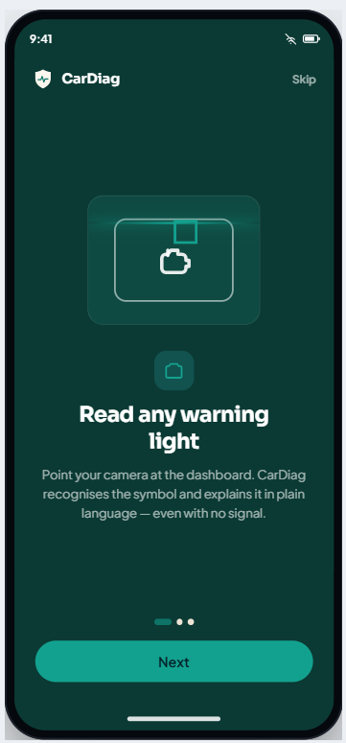  Figure 4: Onboarding - introduces the three diagnostic pathways | 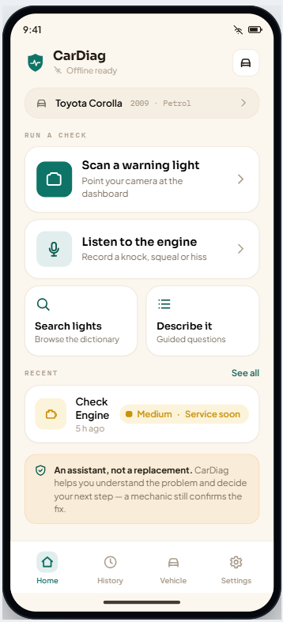  Figure 5: Home hub - every check is one tap away
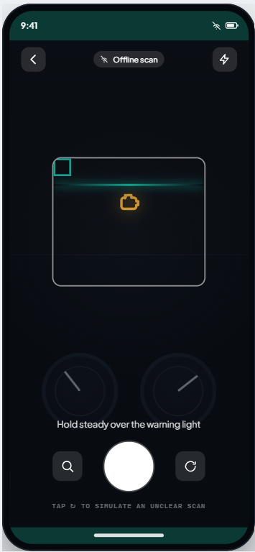  Figure 6: Camera scan - aim-and-capture, fully offline | 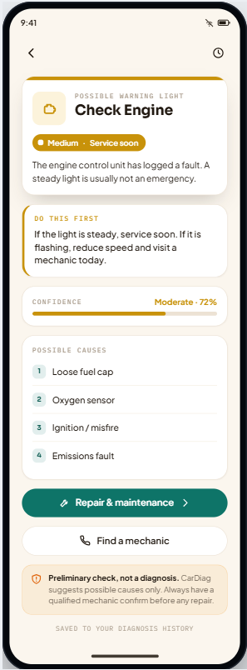  Figure 7: Warning-light result - urgency, confidence, causes
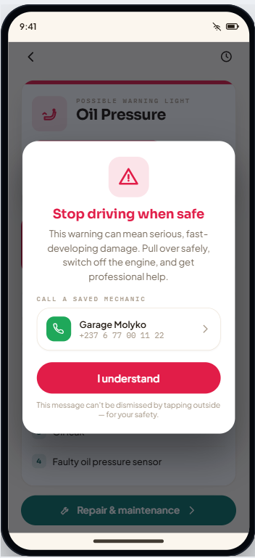  Figure 8: Critical safety prompt - non-dismissible, one-tap call | 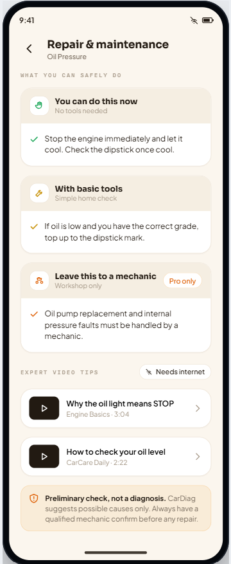  Figure 9: Repair & maintenance - three safety tiers
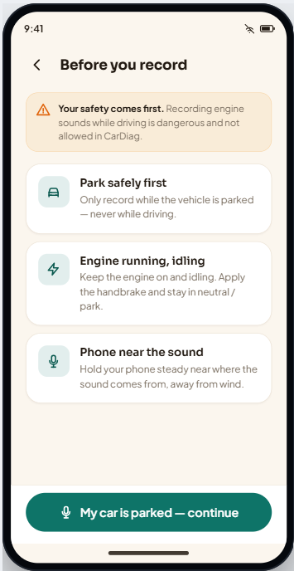  Figure 10: Engine-sound safety gate (timed acknowledgement) | 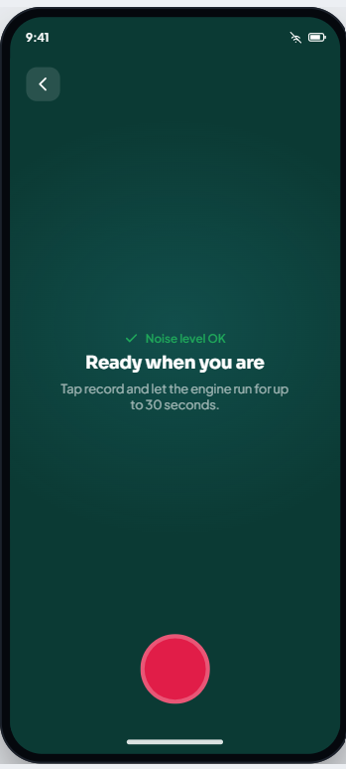  Figure 11: Engine-sound recording with ambient-noise check
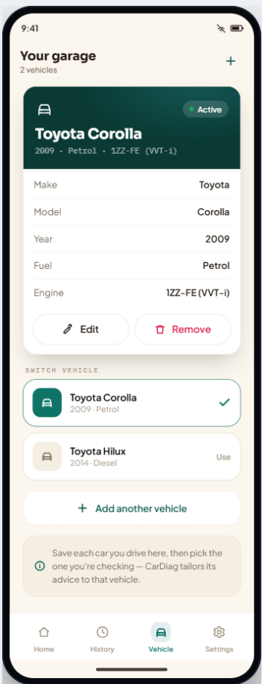  Figure 12: Vehicle garage - save and switch vehicles | 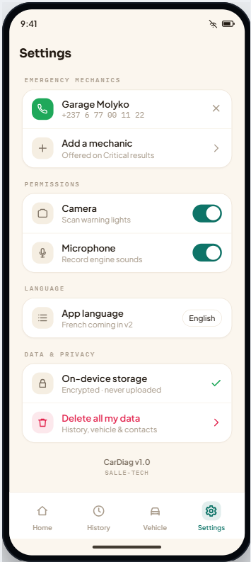  Figure 13: Settings - contacts, permissions, privacy

3.8.1 Home hub
The home hub opens with the wordmark and a calm “Offline ready” status, followed by a strip showing the active vehicle. The three diagnostic pathways are presented as large, friendly cards - “Scan a warning light” (the primary, filled card), “Listen to the engine”, and a pair of smaller cards for “Search lights” and “Describe it”. A “Recent” entry surfaces the last diagnosis with its urgency badge, and the brand-promise disclaimer closes the screen. This layout satisfies the three-tap rule: any check is one tap from home (Figure 5).

3.8.2 Result and safety
The result screen leads with a coloured band and an icon tile in the urgency colour, the fault name, and a solid urgency badge. A bordered “Do this first” card gives the single most important action; the confidence meter, possible causes and actions follow. For High and Critical urgency, a modal interrupts the flow: it explains the danger, offers one-tap calling of a saved mechanic, and - for Critical faults - cannot be dismissed by tapping outside and keeps its acknowledgement button disabled for three seconds so the message is actually read. When confidence is low, the screen deliberately refuses to name a fault and instead routes the user to manual search (Figures 7 and 8).

3.8.3 Engine sound
The sound pathway is intentionally slow and careful. A safety gate lists the rules (park first, engine idling, phone near the sound) and keeps its continue button disabled for four seconds. Recording happens on a dark, focused screen with a live waveform and a thirty-second limit; an ambient-noise check runs first. Afterwards, a short set of follow-up questions refines the result before the assessment is shown (Figures 10 and 11).

3.8.4 Repair and maintenance
Repair guidance is split into three clearly separated tiers - “You can do this now” (no tools), “With basic tools”, and “Leave this to a mechanic” (workshop only, marked “Pro only”) - so users never attempt something unsafe. Expert-video links appear below, badged “Needs internet”; tapping one while offline opens a sheet explaining that the written steps work offline and the video will open once a connection is available (Figure 9).

4. Frontend Implementation
The frontend is a native Android application written in Kotlin with Jetpack Compose. It faithfully implements the “Trusted Companion” design and all sixteen screens, and it is structured so that the machine-learning models, backend services and database from later tasks can be attached with minimal change.

4.1 Architecture Overview
The application follows the Model–View–ViewModel (MVVM) pattern recommended in Task 4, with a light, clean-architecture-style separation of concerns:
- Model / domain - pure Kotlin data types and enumerations with no framework dependencies (warning lights, engine sounds, urgency, repair tips, history entries, vehicles, contacts).
- Data layer - repository and service interfaces that the rest of the app depends on, plus the in-code knowledge base and the current mock implementations.
- ViewModel - a single application view-model that holds the UI state and the navigation back-stack and talks only to the interfaces, never to a concrete data source.
- View - the Compose screens and the shared component library, which render the state and raise user events back to the view-model.
The key architectural decision for a “frontend-first” delivery is that the View and ViewModel depend on abstractions. Today those abstractions are satisfied by mock objects; tomorrow they can be satisfied by a Retrofit-based client, a Room (SQLite) database and a TensorFlow Lite model runner. Because the dependency points inward to interfaces, none of the UI code has to change when the real backend arrives.

4.2 Technology Stack
Layer | Choice | Justification
Language | Kotlin 2.0.21 | Modern, null-safe, the recommended Android language.
UI | Jetpack Compose + Material 3 | Declarative UI; matches the deployment-diagram decision; fast iteration.
Min / target SDK | minSdk 26 (Android 8.0) / latest | Broad device coverage per NFR07; single APK.
Architecture | MVVM + repository/service interfaces | Testable, decoupled, backend-ready (Task 4).
Fonts | Downloadable Google Fonts | Brand typefaces without bundling binaries; graceful fallback.
Build | AGP 8.7.3 / Gradle 8.14 / JDK 21 | Standard Android toolchain.

4.3 Project Structure
The application source is organised by responsibility under a single package, so each concern is easy to locate and the backend seam is obvious:
com.salletech.cardiag
MainActivity.kt edge-to-edge host; owns the view-model; wires system back
CarDiagApplication.kt application entry point
model/ pure domain types + Urgency enum (no framework deps)
data/
KnowledgeBase.kt in-code catalogue (mirrors the bundled DS1 data)
CarDiagRepository.kt INTERFACE: knowledge + user data (history/vehicles/contacts)
DiagnosisService.kt INTERFACE: simulateScan / analyzeSound / guidedAssessment
MockCarDiagRepository.kt in-memory implementation (the only one for now)
MockDiagnosisService.kt canned results (the only one for now)
ui/
AppViewModel.kt UI state + navigation back-stack
Navigator.kt sealed Screen hierarchy with typed parameters
theme/ Color, Type (Google Fonts), Shape, Theme tokens
icons/ interface icons, dashboard symbols, logomark (vector)
components/ TopBar, buttons, badges, confidence, disclaimer, nav, sheets
screens/ one composable file per screen (16 screens)
CarDiagRoot.kt theme host; per-screen system-bar handling; screen switch

4.4 Domain Model and Knowledge Base
The domain layer defines the vocabulary of the app as small, immutable Kotlin types. The urgency scale is an enumeration that carries its own colour, label and action so the UI never hard-codes those values. The knowledge base mirrors the data that, in production, will live in the bundled SQLite store (data store DS1 in Task 4): eight warning-light records and five engine-sound categories, each with a plain-language description, possible causes, a recommended first action, three tiers of repair suggestions, and expert-video references. Holding this catalogue behind the repository interface means the screens are already written against “whatever the repository returns”, so replacing the in-code catalogue with a database query later is transparent to the UI.

4.5 Data Layer and Backend-Readiness
Two interfaces form the seam between the frontend and the future backend:
interface CarDiagRepository {
// knowledge
fun warningLights(): List<WarningLight>
fun engineSounds(): List<EngineSound>
fun light(id: String): WarningLight?
// user data (history, vehicles, contacts) - CRUD
fun history(): List<HistoryEntry>
fun addHistory(entry: HistoryEntry)
fun vehicles(): List<Vehicle>; fun addVehicle(v: Vehicle) /* ... */
}

interface DiagnosisService { // the ML / inference seam
fun simulateScan(): DiagnosisResult
fun analyzeSound(): DiagnosisResult
fun guidedAssessment(area: String): DiagnosisResult
}
In this build, MockCarDiagRepository keeps everything in memory (seeded with the sample vehicles, history and contact used throughout the prototype) and MockDiagnosisService returns realistic canned results. Attaching the backend is then purely additive:
- Database (Task 6) - implement CarDiagRepository with a Room/SQLite-backed class for the bundled knowledge base and encrypted local storage for user data.
- Backend / sync - add a Retrofit-based implementation for online fault-database synchronisation and curated video links.
- On-device ML - implement DiagnosisService with a TensorFlow Lite model runner for image and audio classification.
The concrete implementations are selected in one place (the activity / a future dependency-injection module); no screen or view-model code changes. This is exactly the extensibility the requirements and Task 4 called for.

4.6 Navigation
Navigation uses a lightweight in-app router rather than a URL-style navigation graph, because several destinations carry rich domain objects (a result, a repair target, a history entry) that are awkward to serialise into string arguments. A sealed Screen type enumerates every destination and its typed parameters; the view-model keeps a back-stack of screens and exposes go() and back() operations that mirror the prototype’s flow exactly. The device back button is wired to the same back() operation, and the immersive screens (splash, onboarding, camera, sound recording) are flagged so the status-bar icons switch to light automatically.

4.7 State Management
A single AppViewModel owns the application state - whether onboarding is complete, the list of saved vehicles and the active one, the diagnosis history, and the saved emergency contacts - as observable Compose state. Screens read this state and call view-model methods to mutate it (for example, saving a completed diagnosis to history, adding a vehicle, or deleting all data). Keeping state in the view-model means it survives recomposition and configuration changes, and it gives the future persistence layer a single, well-defined place to load from and save to.

4.8 Theming and Rendering
The design tokens from Section 3 are implemented as Compose composition-locals: a colour set and a type set are provided at the root and consumed by every component, so the whole app can be re-themed from one place. The three brand typefaces are loaded as downloadable Google Fonts with a system fallback, so no font binaries are shipped and the app degrades gracefully if the provider is unavailable. The interface icons and dashboard symbols are rendered from their vector path definitions at runtime, and the logomark is drawn as a vector, keeping every graphic resolution-independent and the install size small. The app draws edge-to-edge and manages the system bars per screen.

4.9 Diagnostic Flows and Safety Behaviour
The implemented flows map directly onto the Task 4 use cases:
- Warning-light scan (UC01) - the camera screen presents an aim-and-capture experience and a scanning animation, then resolves to a result that is automatically saved to history. A low-confidence outcome triggers the manual-search fallback (UC11) instead of guessing.
- Manual search (UC02) - a fully offline dictionary with live, category-filtered search over the warning-light catalogue.
- Engine sound (UC03) - safety gate, ambient check, timed recording and follow-up questions, ending in an assessment.
- Repair suggestions (UC04) - three repair tiers plus expert-video links with an offline notice.
- History (UC06) - browse, filter, view detail, edit a note and delete with confirmation.
- Safety prompt (UC07) - High shows an acknowledgement modal; Critical shows a non-dismissible modal with a three-second read delay and one-tap dialling of a saved mechanic via the phone’s dialler.
Together these realise the trust model at the heart of the project: the app gives a confident-but-honest preliminary view, always shows a safety disclaimer, and escalates deliberately when a fault is dangerous.

4.10 Permissions and Privacy
Camera and microphone permissions are declared in the manifest and requested at runtime using the Android Activity Result API, at the point of first use, with a clear in-app rationale explaining that images and audio are processed on the device and never uploaded (NFR05). Manual search and the dictionary work without granting any permission, so a cautious user can still get value from the app. A “Delete all my data” action in Settings clears history and contacts in one step (NFR08).

4.11 Offline-First Behaviour
All core features run entirely from in-app data and on-device logic: the warning-light dictionary, explanations, urgency, repair text, history, the safety layer and the simulated classifiers require no network. Online-only features (expert videos and, in future, database sync) are clearly marked and degrade to a helpful message when offline. This honours FR11 and NFR02 and the Cameroonian connectivity context that motivated them.

4.12 Build and Run
The project is a standard Gradle Android project under the repository’s android/ folder. To build and run it:
- Open the android/ folder in Android Studio; let it sync Gradle (this also provisions the Gradle wrapper).
- Select an emulator or a connected device running Android 8.0 (API 26) or higher.
- Press Run, or build a debug APK from the command line with the assembleDebug task.
The debug APK is produced at app/build/outputs/apk/debug/app-debug.apk. The application requires no server or configuration to run, because all data and diagnosis are local in this build.

4.13 Requirements Traceability
The table maps the principal requirements addressed by this task to the part of the implementation that satisfies them.
Requirement | Where it is implemented
FR01 Camera scan | Camera screen + DiagnosisService.simulateScan()
FR02 Manual search | Manual-search screen over KnowledgeBase warning lights
FR04 Light explanation | Result screen (name, description, causes, first action)
FR05/FR07/FR18 Sound | Sound safety gate, recorder, follow-up questions
FR08 Urgency | Urgency enum + urgency badge on every result
FR09/FR19 Repair & tips | Repair screen, three tiers + preventive tips
FR10 Expert videos | Repair screen video links with offline notice
FR11 Offline | In-code knowledge base; no network on core flows
FR13 Disclaimer | Mandatory disclaimer component on all results
FR14/FR14a Referral | Safety modal with saved-mechanic dialling
FR15 Vehicle profile | Vehicle garage screen (CRUD + active vehicle)
FR16 History | History list + detail (note edit, delete)
FR17 Confidence | Confidence meter; low confidence suppresses fault name
FR22 Guided symptoms | Guided-symptoms questionnaire screen
NFR01 Usability | Three-tap home hub, plain language
NFR05 Privacy | Runtime permissions with on-device rationale
NFR08 Data security | Delete-all-data action; local-only storage
NFR11 Accessibility | Colour-plus-label urgency; contrast; scalable layout

5. Challenges and Key Design Decisions

5.1 Choosing a reassuring identity over a technical one
The strongest tension in the requirements was trust: users want help but fear an over-confident tool, and mechanics fear being replaced. Selecting the warm “Trusted Companion” direction, and committing to the “assistant, not a replacement” promise, turned that tension into a clear design brief rather than a problem to be patched late.

5.2 Communicating uncertainty responsibly
Because the diagnosis is preliminary, the interface had to avoid implying certainty. The confidence meter, the suppression of specific fault names on low confidence, and the mandatory disclaimer were therefore treated as first-class components rather than optional extras.

5.3 Designing safety interruptions that are actually read
For dangerous faults, a normal dialog is too easy to dismiss reflexively. The non-dismissible modal with a short enforced read delay and a one-tap call to a saved mechanic was the design response, balancing safety against the risk of frustrating the user on minor faults (which use a gentler banner).

5.4 Building a frontend that does not have to be rewritten
Delivering a frontend before the backend risks baking in assumptions that later force a rewrite. Routing all data and diagnosis through interfaces, with mock implementations behind them, was the decision that lets Task 6 add a real database and on-device models by addition rather than modification.

5.5 Custom navigation for rich screen parameters
Standard string-argument navigation is awkward when screens carry whole domain objects. A small sealed-type router with a back-stack in the view-model proved simpler, type-safe and a faithful match to the prototype’s flow.

6. Conclusion
Task 5 has delivered the three required outputs for the CarDiag application. The app identity establishes a recognisable, trustworthy character built around the promise of an assistant rather than a replacement, expressed through the CarDiag name, the pulse-shield logomark, and the “Your pocket diagnostic” tagline. The visual design provides a complete, accessible, token-based design system - colour, type, shape, iconography and components - that gives all sixteen screens a coherent and reassuring look while honouring the project’s safety and usability requirements. The frontend implementation realises that design as a native Kotlin and Jetpack Compose Android application that runs fully offline, follows the MVVM architecture mandated in Task 4, and is deliberately structured behind repository and service interfaces so that the database, backend and on-device machine-learning models of Task 6 and beyond can be attached without changing the user interface.

